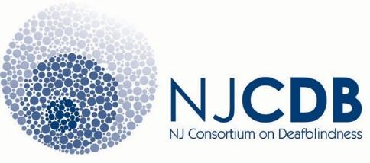

Training Request

School Name/Organization: Address: Phone:

School District Name(if applicable);

Person or Group Requesting Training:

Date Range of Training Request:

How many do you anticipate attending:

Type of Training:

____Cortical Visual Impairments ____Calendar/Schedule System

____Assistive Technology ____Communication

____Person-Centered Planning ____Behavior

____Transition ____Collaborative Team

____Interveners ____Usher Syndrome

____National Intervener Certification

____Deafblind Etiologies

____CHARGE

____Hearing and Visual System and Educational Consideration/Strategies (DB101)

Or submit a request here:___________________________________________________

Contact:
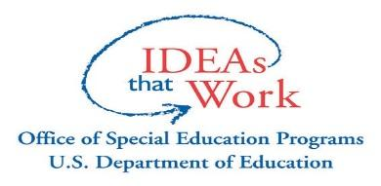
U.S. Dept. Education #H326C080039.

Angel Perez Michelle Ragunan
pereza@tcnj.edu ragunan@tcnj.edu
609-771-2744 609-771-3038
256-599-1254

