Technical Assistance Form

Student’s Name:________________________________________________

Student’s DOB:_________________________________________________

Name of person requesting technical assistance:_____________________________________

Role of person requesting technical assistance:______________________________________

Phone Number:___________________________________________

Email:____________________________________

Best Method and time for us to contact you:_________________________________________

Describe target areas that you want NJCDB to address during consultation:________________

Have parents been notified of this TA request?_______________________________________

Parent’s Name:______________________________________________________

Parent’s email:_______________________________________________

Parent’s Phone Number:_______________________________________

School:_____________________________________________________

Address:___________________________________________________

Teacher’s Name:____________________________________________

Teacher’s Email:____________________________________________

School Administrator’s Name:__________________________________________________

School Administrator’s Email:__________________________________________________

Is the child registered with NJCDB?_____________________________________________

Contact:
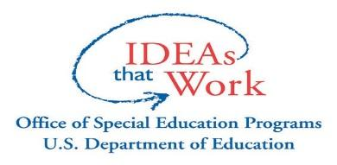
U.S. Dept. Education #H326C080039.

Angel Perez
pereza@tcnj.edu
609-771-2744
256-599-1254

