Save The Date!

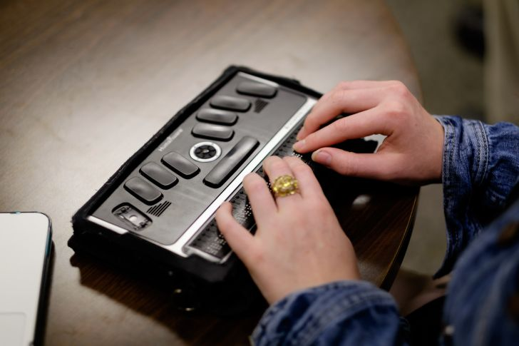

  - Assistive Technology for People who are Deafblind
The College of New Jersey
New Jersey Center on Deafblindness
2000 Pennington Rd
Ewing, New Jersey 08628
Feb. 9th @ 9:00 a.m.
Contact us for more information:
609-771-3038
ragunan@tcnj.edu

