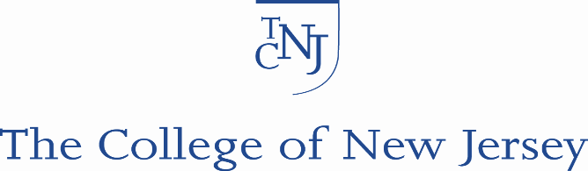

TCNJ Institutional Review Board

RESEARCH SUBJECT INFORMED CONSENT FORM

Dear Prospective Research Participant:
You are being asked to be a volunteer in a research study. Please read this consent form carefully, and ask as many questions as you like before you decide whether you want to participate in this research study. You may also ask questions at any time before, during, or after your participation in this research. You are encouraged to take your time in making your decision.

GENERAL INFORMATION
Project Title: Father school experiences study
Approved protocol number : 1174-32 Approval date : 5/1/2017 Expiration date: 4/30/2018
Project sponsor(s): The College of New Jersey
Principal Investigator: Dr. Nadya Pancsofar, Department of Special Education, Language, and Literacy, School of Education, The College of New Jersey, P.O. Box 7718, Ewing, NJ 08628; Email: pancsofa@tcnj.edu; Telephone: 609-323-7310
Co-Investigator(s) on the project: Dr. Jerry Petroff

PROJECT INFORMATION
1. Purpose of the Research: Very little is known about the experiences of fathers in school settings, particularly for fathers of children with disabilities. This research study will provide more detailed insight into the school involvement experiences of fathers of children with deaf blindness and highlight ways in which educators can better meet the needs of these fathers in the educational settings.
2. Exclusion/ Inclusion Criteria: This study will include only fathers of children with deaf blindness as this research aims to understand the perspectives and experiences of these fathers. Fathers have been under-represented in Educational research, and most studies of parent-school involvement have focused on mothers.
3. Research Procedures: All fathers of children and youth ages 3-21 years and classified as deaf blind will be recruited to complete a questionnaire on their school involvement experiences and attitudes. Participants will be asked to complete on-line questionnaires at one time-point. Each questionnaire should take approximately 20-30 minutes to complete.
4. Potential Risks and Discomforts: There is no more than very minimal risk for participating in this research study.
5. Potential Benefits of the Research: This research study on fathers’ school experiences will inform the work of special educators and related service personnel, and highlight avenues for intervention and strategies for supportive family-centered partnerships. Participants in this research may receive indirect benefits via general improvements to the field of special education through the collection of this data and dissemination of these results.
6. Compensation for participation: N/A
7. Alternative procedures or treatments: N/A
8. Provision for Confidentiality: This survey is designed to identify only broad categories of data and captures responses that are would not be considered sensitive information. Participants' privacy will be protected as controls for confidentiality have been established. Data will be maintained on single folder that is password protected on the TCNJ secure server. Individual results will not be reported. There will be no personally identifying information or contact information collected.
9. Research-related Injury: N/A
10. Contacts for additional information: If you have any questions about the study, you may contact the PI (Dr. Nadya Pancsofar) at the address given above. If you have concerns about the research or about your rights as a participant, please contact Dr. Chu Kim-Prieto, Chair of The College of New Jersey Institutional Review Board (609-771-2695; kim@tcnj.edu).
11. Voluntary participation and the right to discontinue participation without penalty: Your participation in this study is voluntary. You do not have to be in this study if you do not want to be. You have the right to change your mind and leave the study at any time without giving any reason and without penalty. Any new information that may make you change your mind about being in this study will be given to you. You will be given a copy of this consent form to keep. You do not waive any of your legal rights by signing this consent form.
12. Conflict of Interest: N/A
13. Additional Information: N/A
The survey can be accessed at: https://www.surveymonkey.com/r/FZ5GZZB

