Picture That

Directions: Each card contains an image and several words. One player will look at the card and try to describe the object pictured as best as they can. They are not allowed to use the words listed on the card.
Or
This game can also be used as a prompt for a round of 20 questions. In this case, one person would be allowed to ask 20 questions to guess what is on their partner’s card.

Use the Target Skill Sheet to record your observations.

Purpose: This game should help you to gather information about several aspects of your client’s communication including: wait time, expressive language, comfort with English, and understanding of abstract language. If played as 20 questions, the game also provides information about the client’s preferences regarding questions.

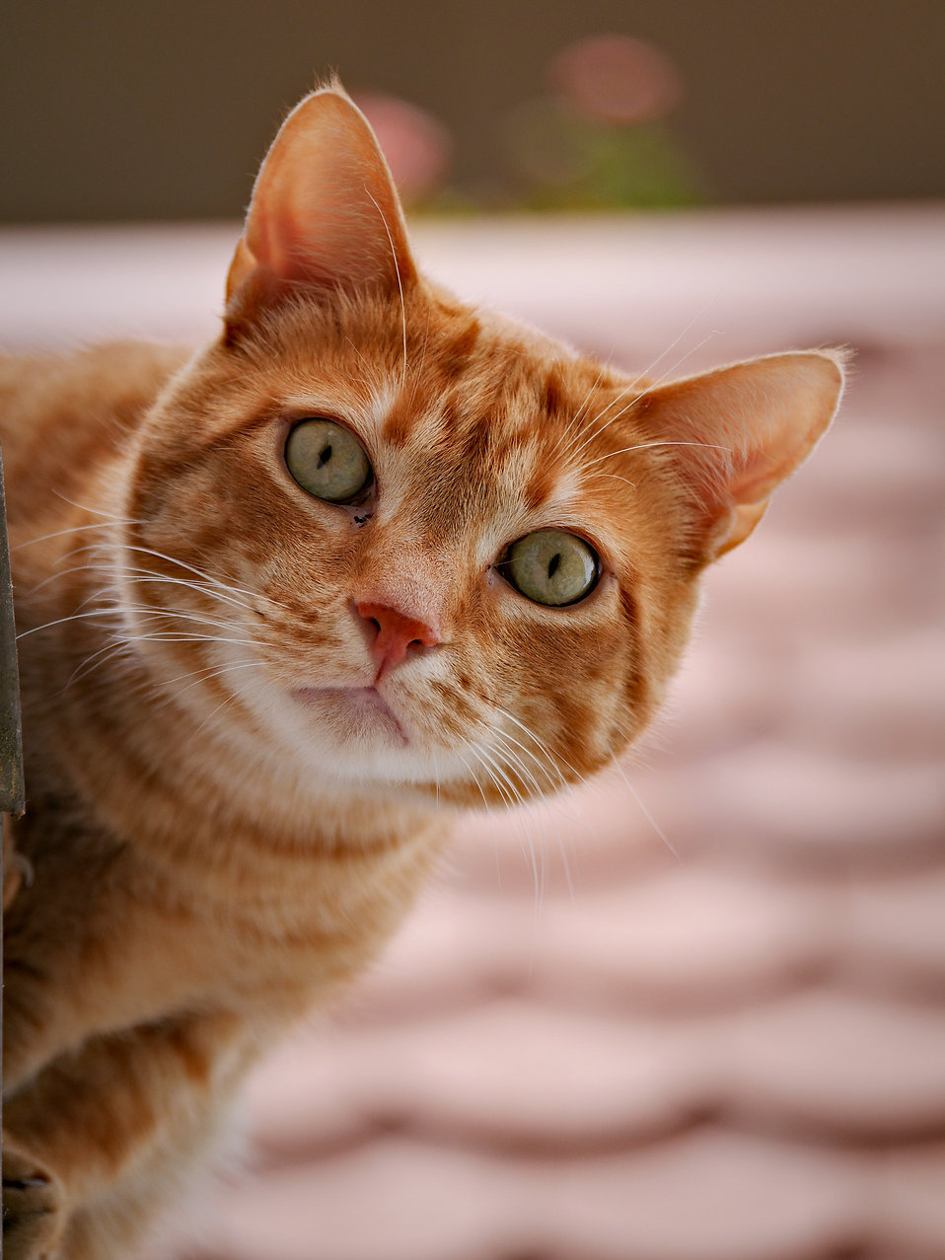  Cat  Milk  String  Kitten  Garfield | 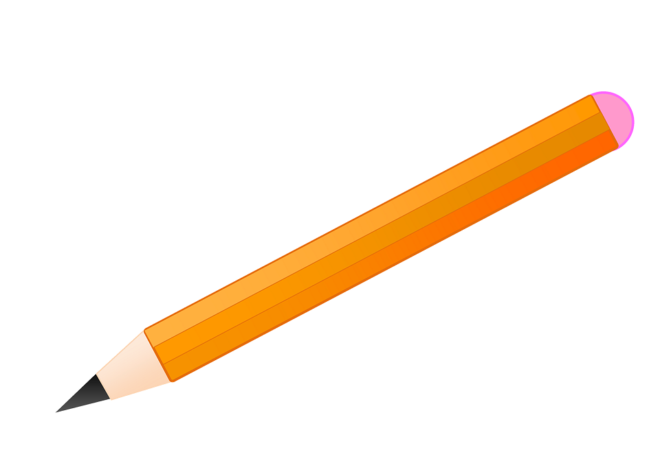  Pencil  School  Writing  Pen  Eraser
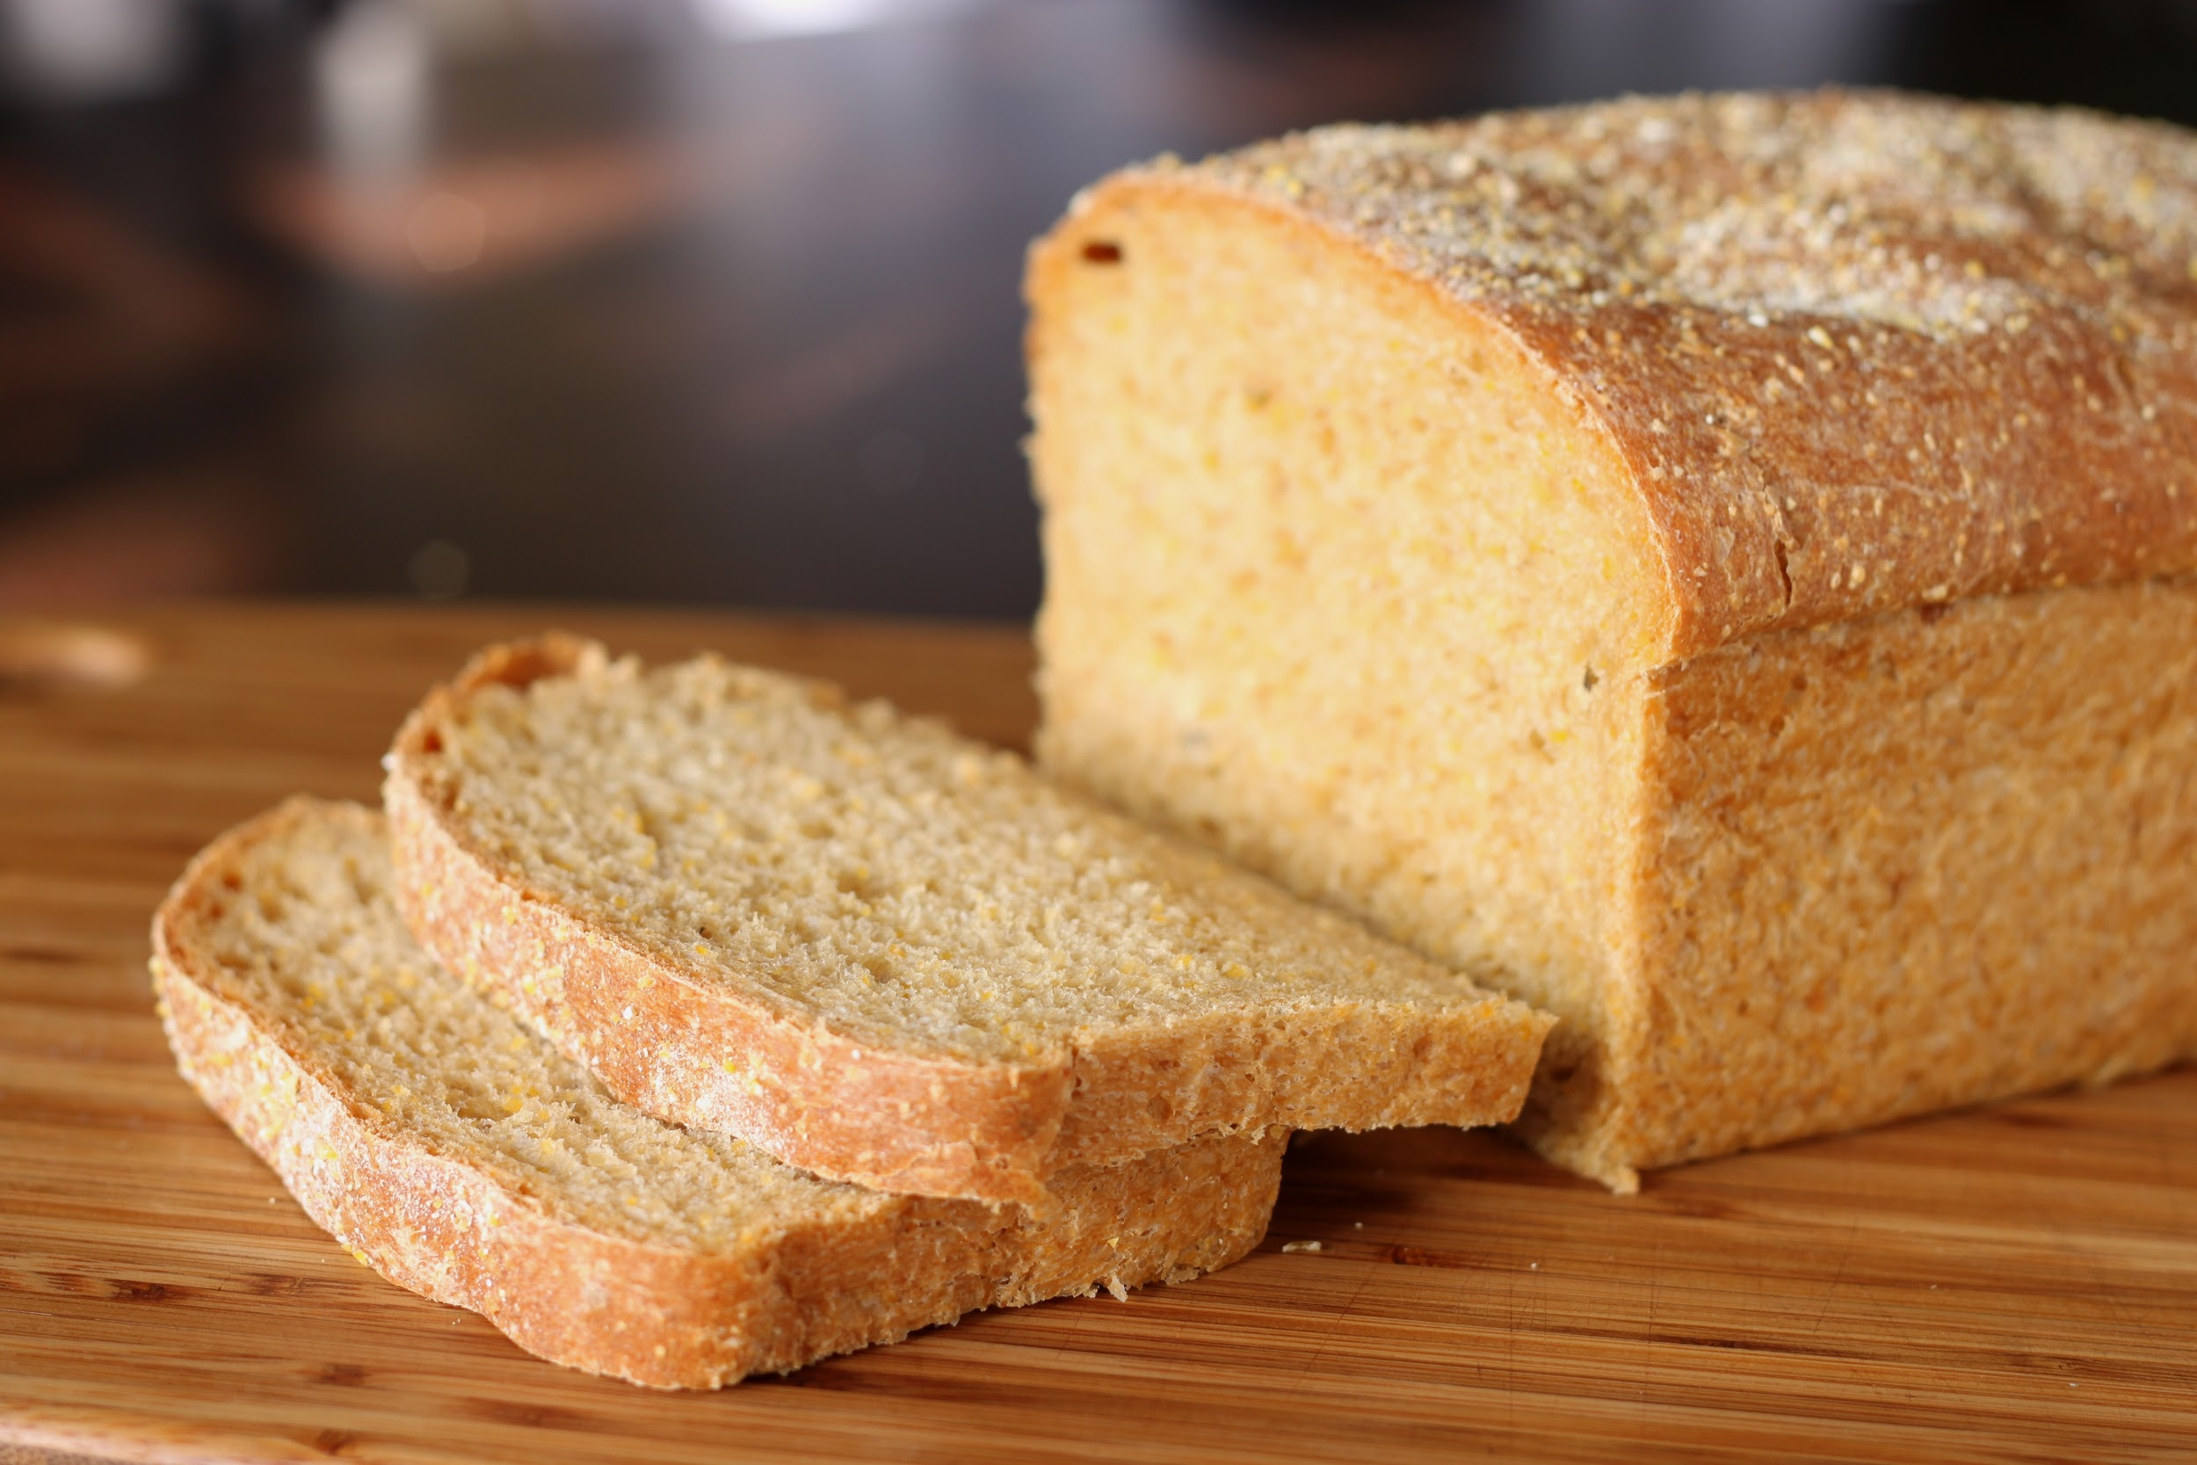  Bread  Bake  Rye  Wheat  Sandwich | Ghost  Boo  Casper  Scary  Haunted
Glasses  See  Face  Look  Lens | 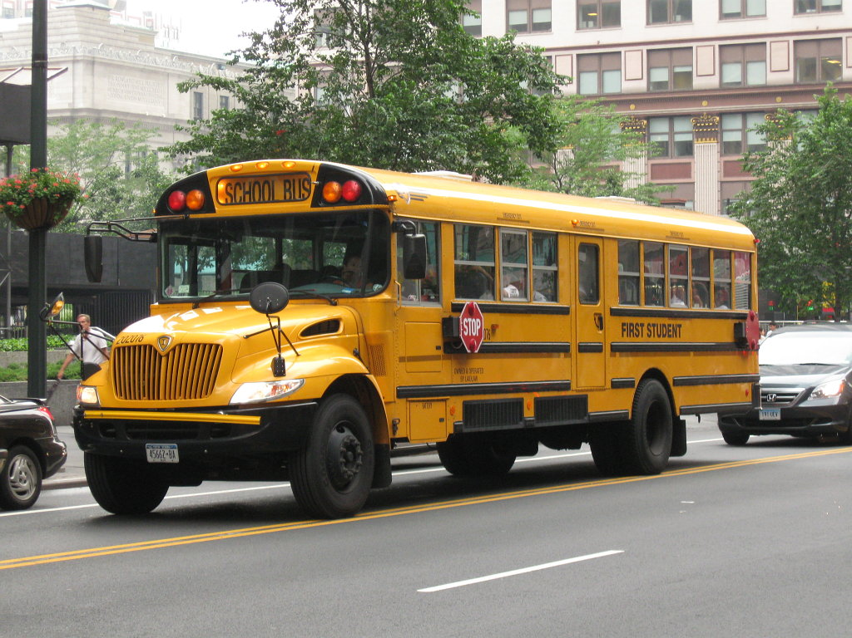  Bus  School  Yellow  Wheels  Round

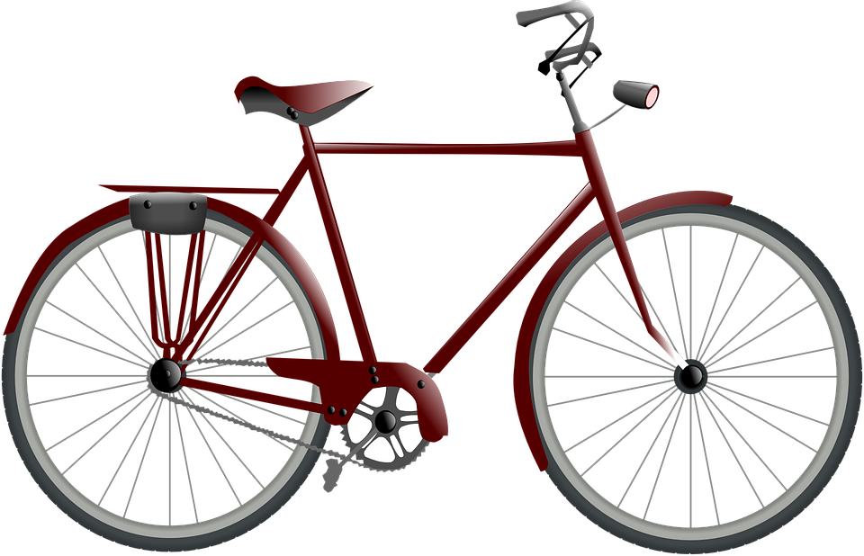Bicycle  Bike  Wheels  Ride  Seat | 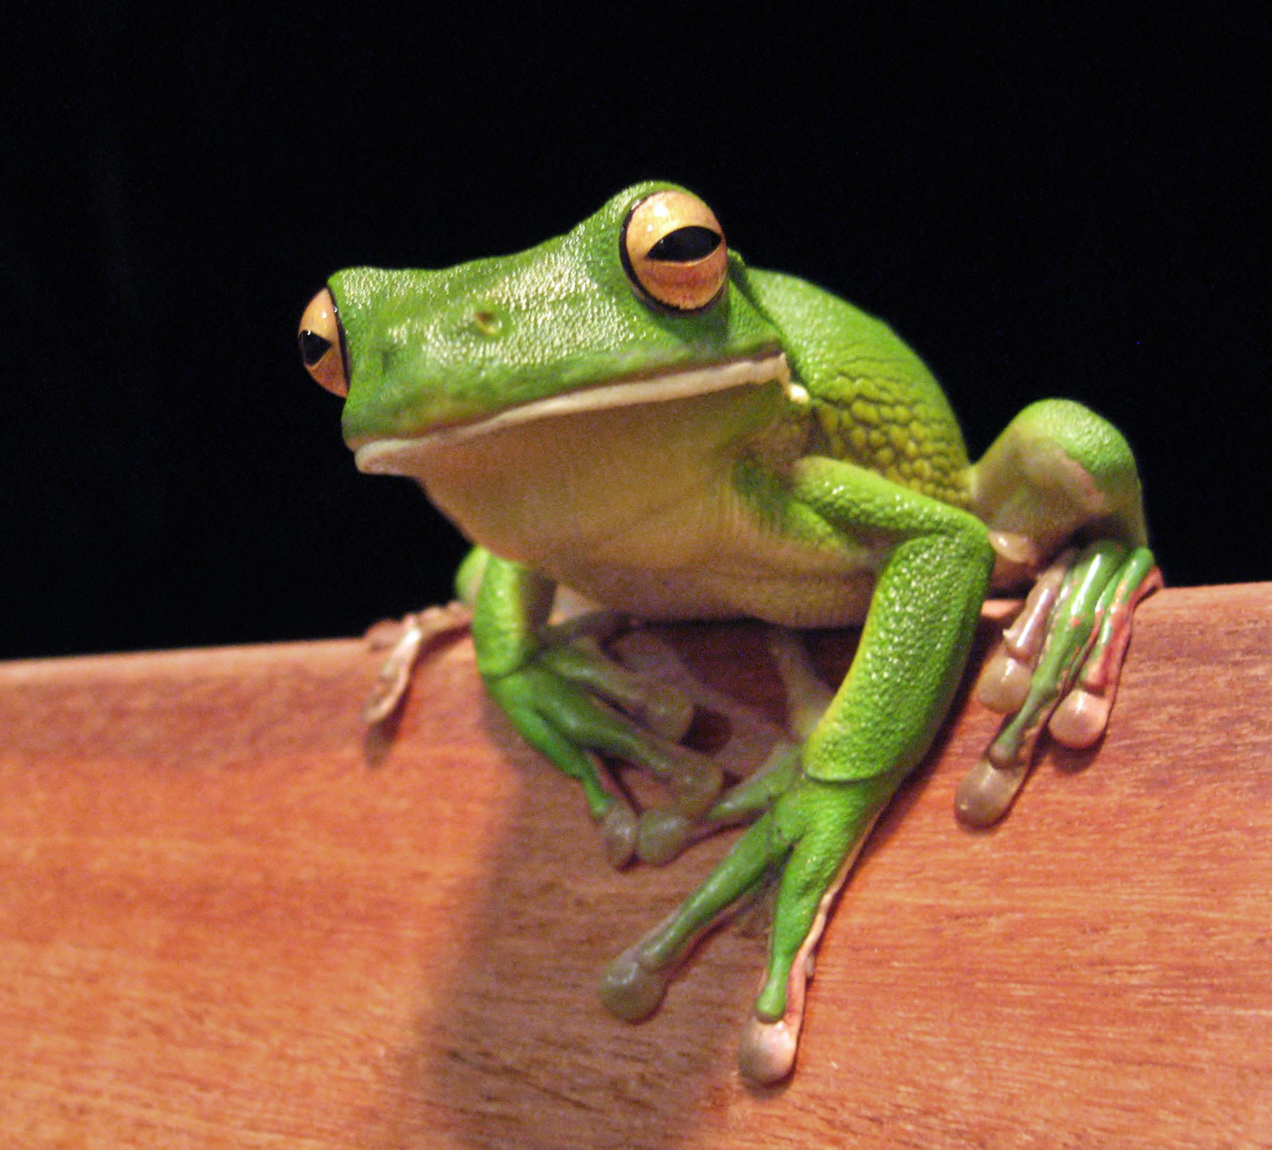  Frog  Hop  Jump  Pond  Green
Dinosaur  T-rex  Old  Extinct  Jurassic Park | The Moon  Sky  Grey  Sun  Stars
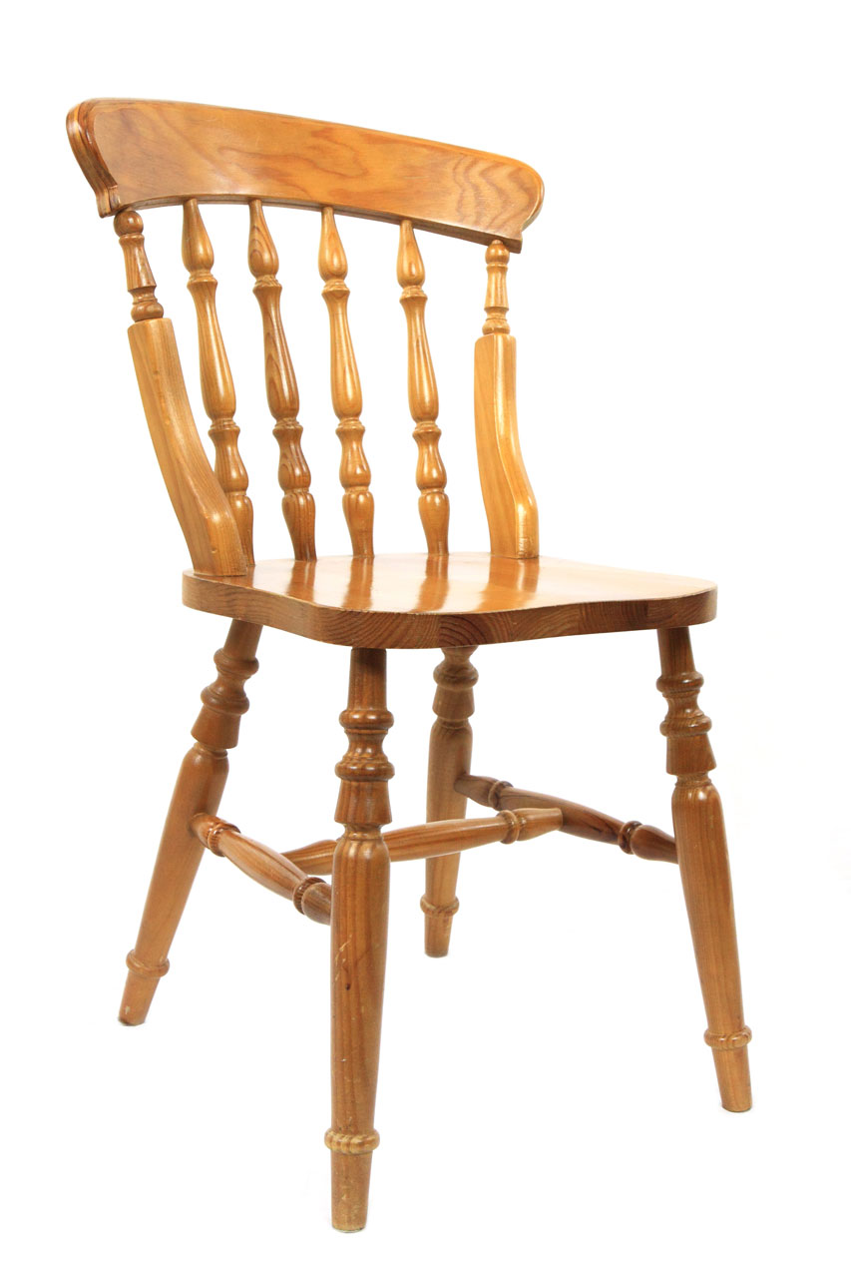  Chair  Desk  Sit  Seat  Table | Balloon  Party  Floating  Pop  Celebration

Snowflake  Cold  Ice  White  Snowman | Ears  Face  Nose  Eyes  Hear
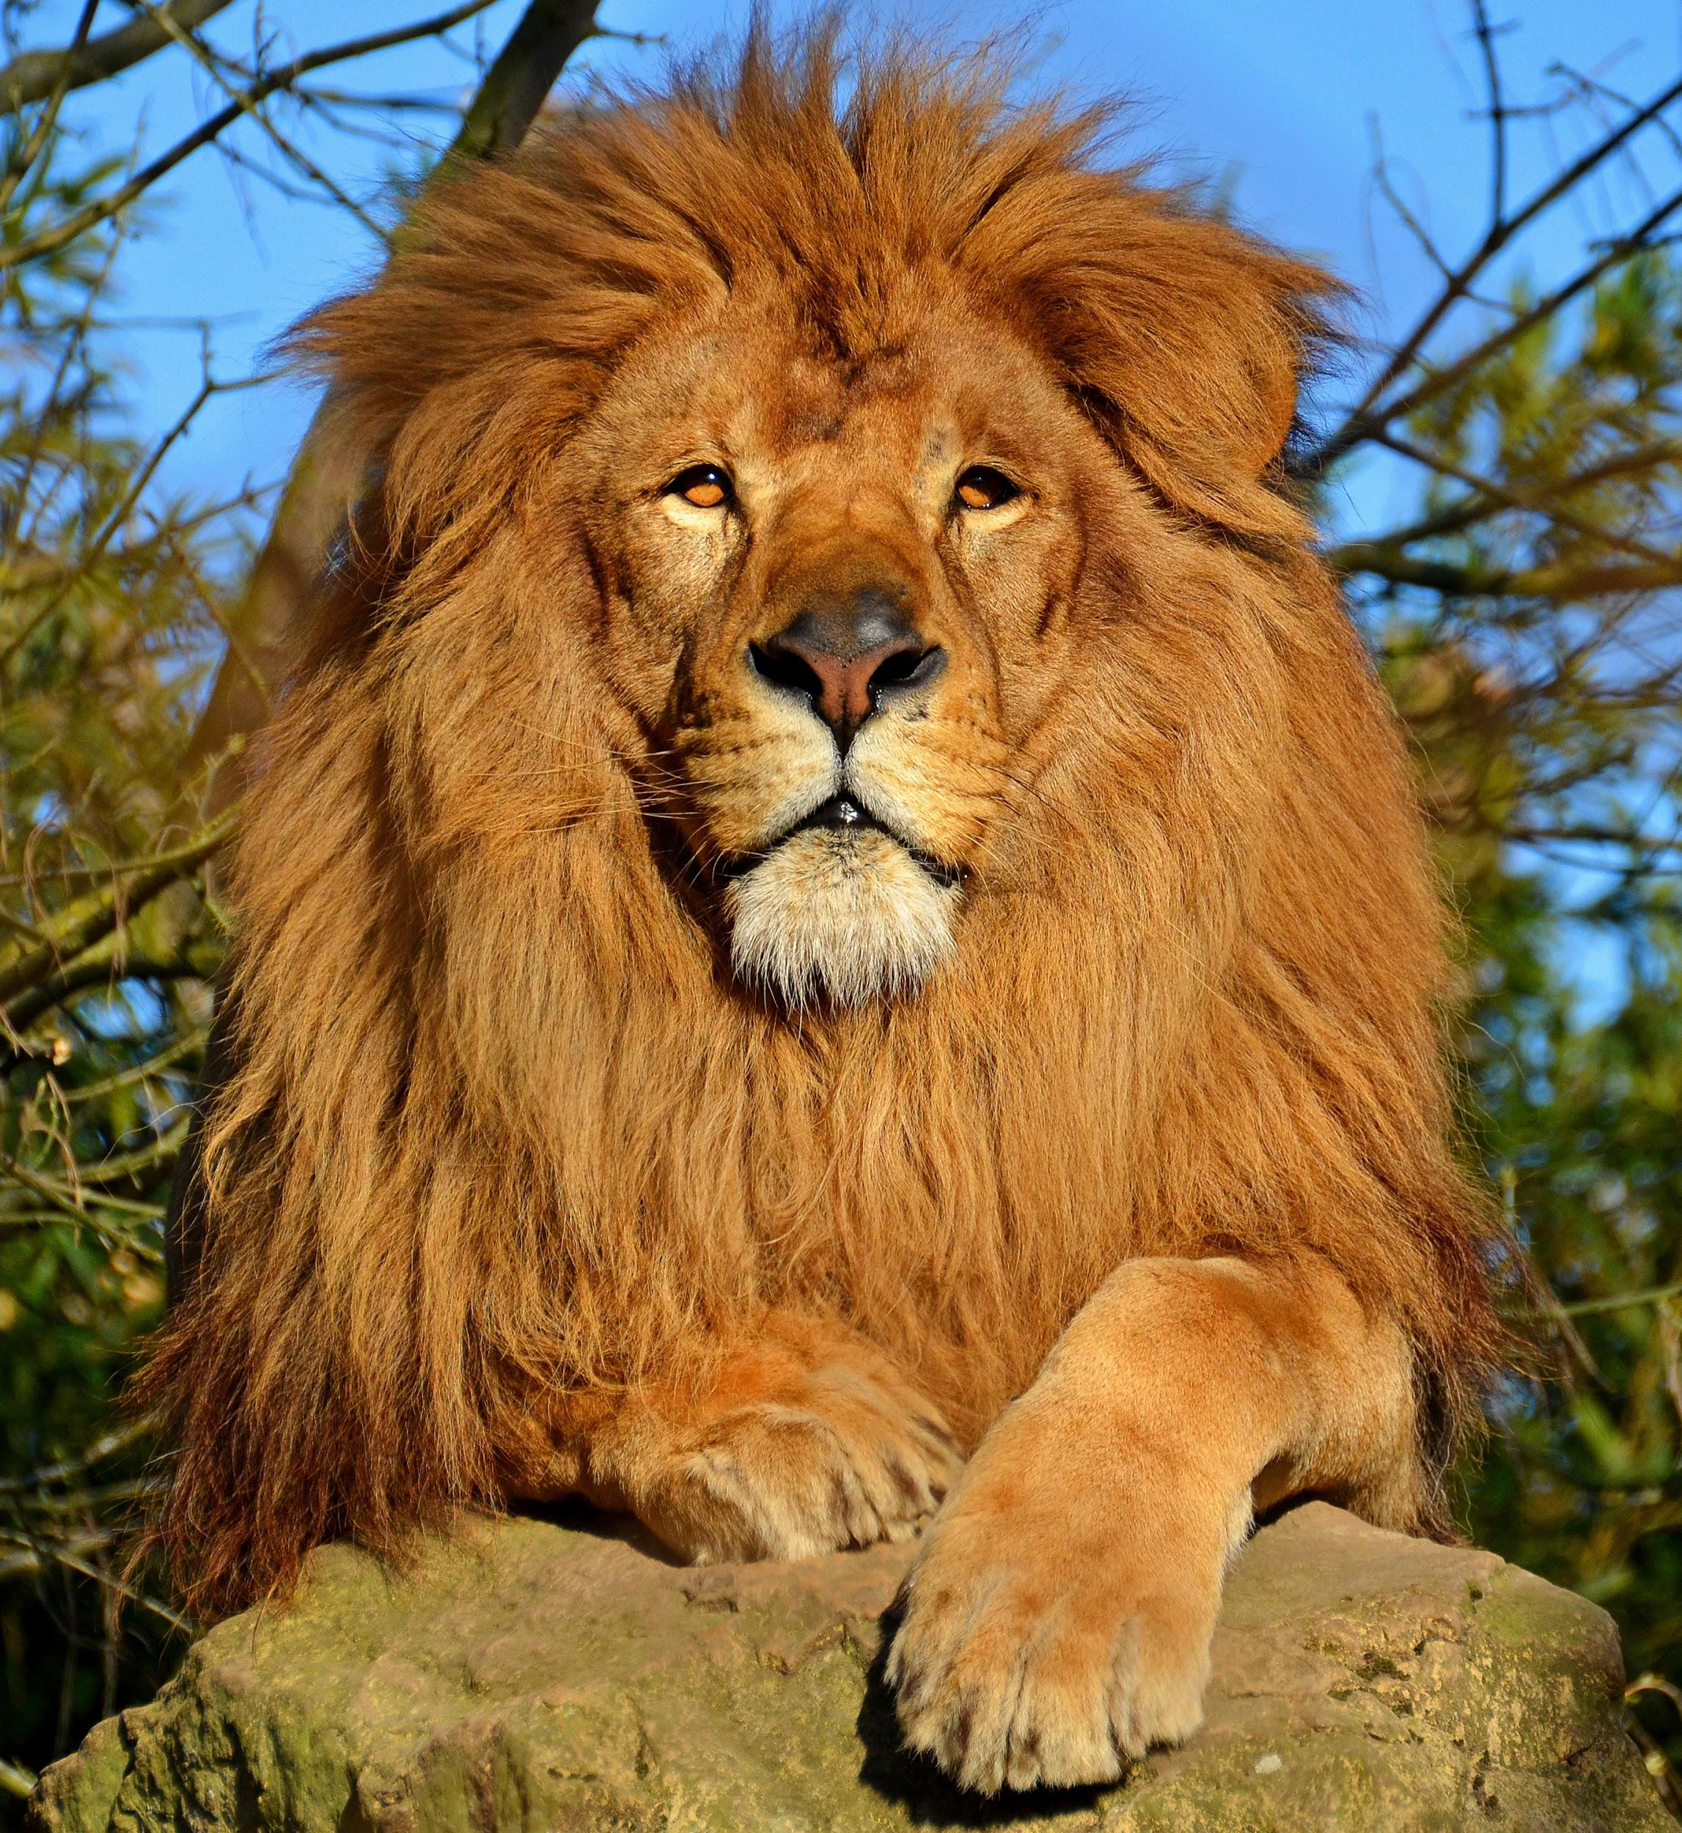  Lion  Cat  Pride  Simba  Zoo | Foot  Leg  Shoe  Feet  Toes
Water  Bottle  Glass  Liquid  Clear | Rocket  Space  Ship  Sky  Planet

Beach  Ball  Sun  Coast  Ocean | 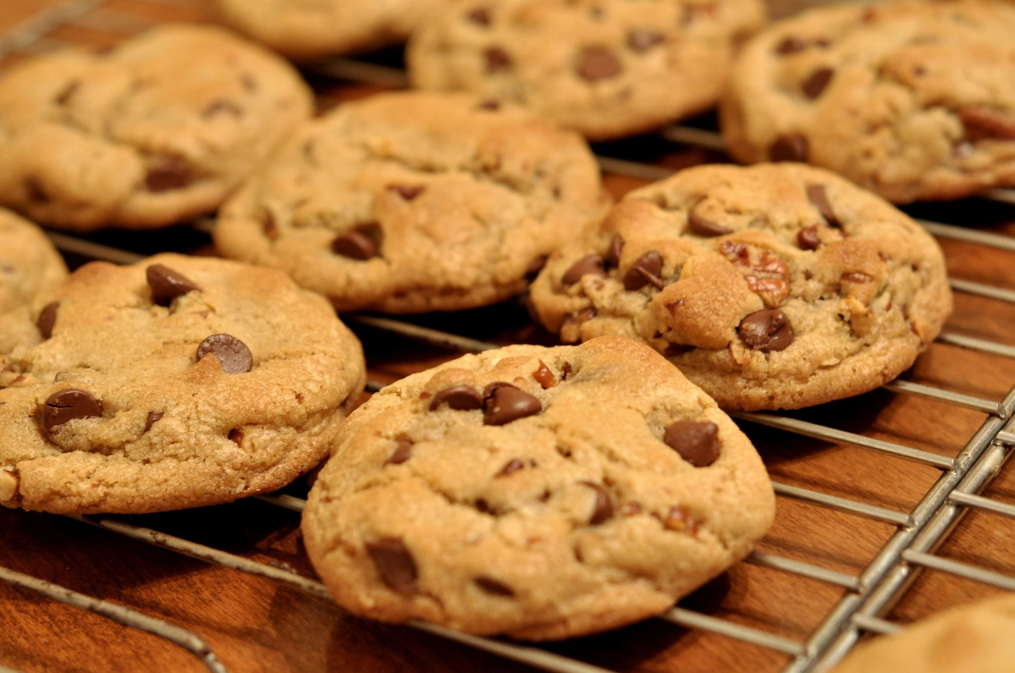  Cookie  Chocolate  Bake  Dough  Oatmeal
Hamburger  Meat  Bun  Food  Sandwich | Mouse  Computer  Ears  Cheese  Trap
Turtle  Shell  Green  Swim  Ocean | 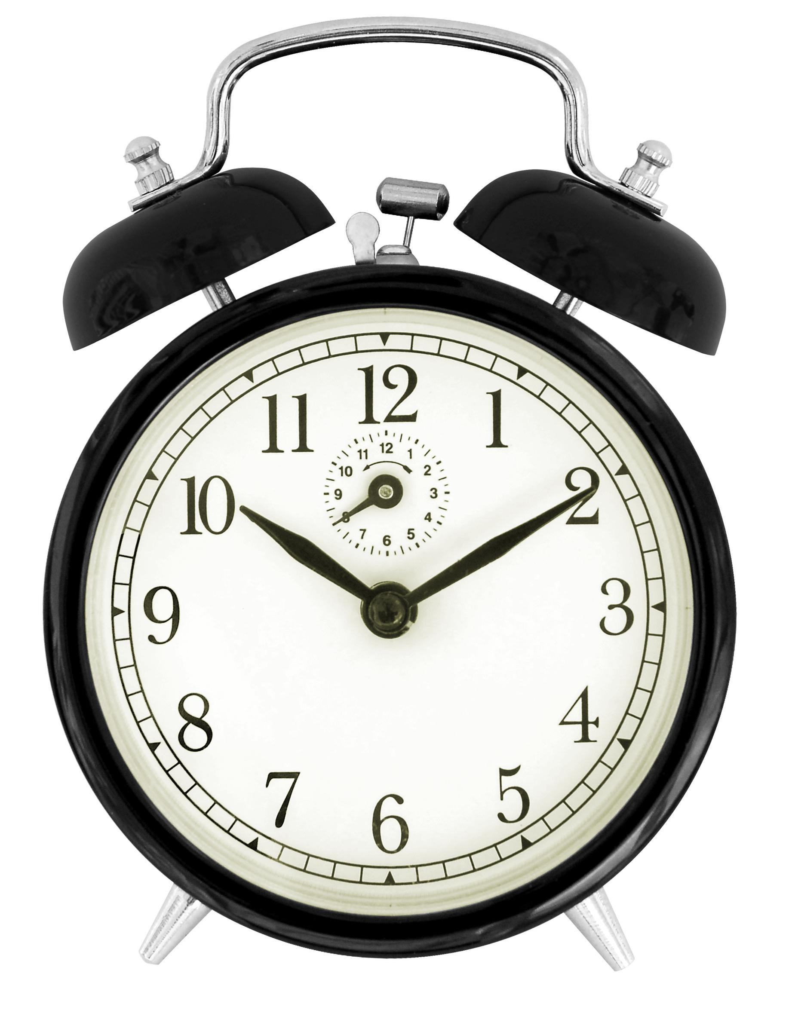  Clock  Time  Hour  Minute  Alarm

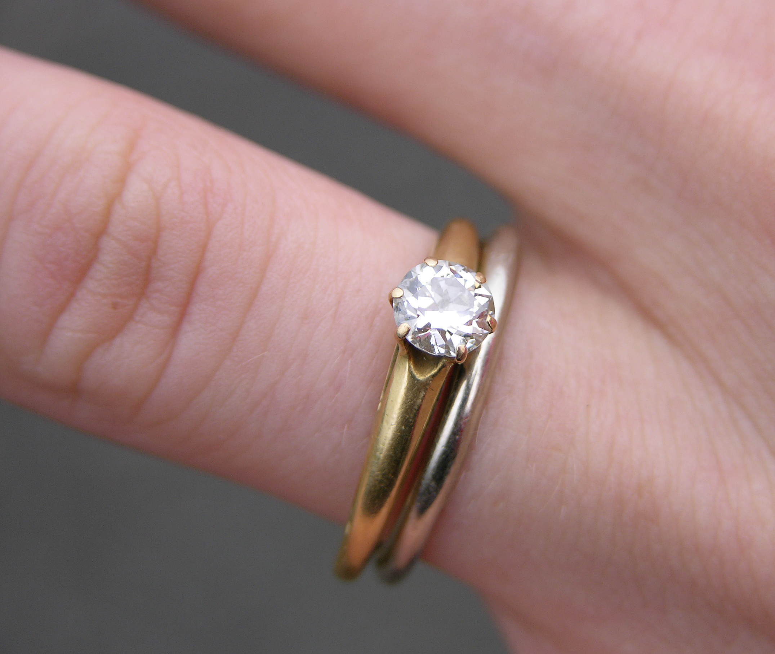  Ring  Finger  Gold  Engagement  Circle | Candle  Stick  Wax  Light  Fire
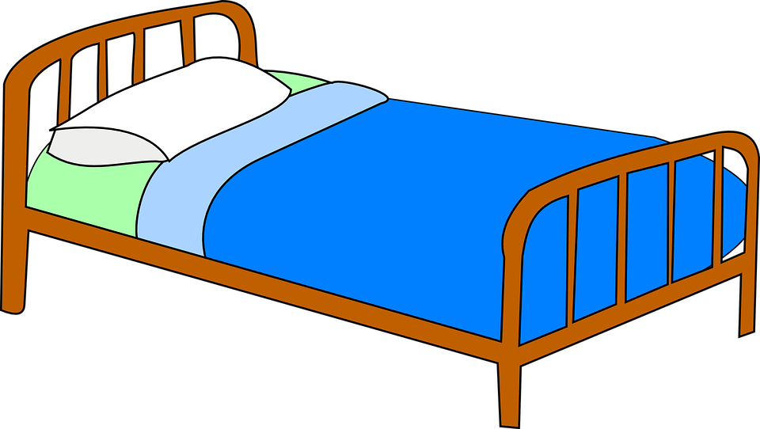  Bed  Sleep  Pillow  Blanket  Night | Book  Page  Words  Read  Study
Cloud  Sky  White  Puffy  Shapes | Airplane  Sky  Fly  Travel  Soar

